**Geocoding Through ArcGIS Online from an On-Premises Portal**

This guide provides information on the process and security of geocoding data from an on-premises portal using ArcGIS Online’s geocoding services, including steps, impact, and frequently asked questions.

**Who Will This Impact?**

This change affects all analysts with creator licenses on the on-premises portal. Geocoding typically occurs when users upload data files (CSV, XLSX, etc.) containing address fields into the portal. During the upload process, users can choose to geocode these fields, receiving longitude and latitude coordinates that are then added to the resulting layer for mapping.

**Important Information**

* **Credit Usage**: Geocoding through ArcGIS Online now costs 40 credits per 1,000 geocodes. A limited pool of credits is available on a first-come, first-served basis. Once depleted, additional credits can be requested using the intake form.
* **One-Way Connection**: Geocoding requests are securely routed from the on-premises portal to ArcGIS Online, which operates in a FedRAMP Moderate environment. Only geocoded results (coordinates) are returned, ensuring a one-directional flow.
* **FedRAMP Compliance**: Security details for this connection are managed under FedRAMP standards. If required, specific security details can be provided for security leads.

**How the One-Way Geocoding Connection Works**

The one-way connection between the on-premises portal and ArcGIS Online is structured to securely route data out of the secure environment and return only the required coordinates. Here’s how the process works:

1. **Initiating the Geocoding Request**:
   * When users upload a dataset with address fields, they initiate a geocoding request. The portal sends address data to ArcGIS Online through a secure connection.
2. **Processing the Request (ArcGIS Online)**:
   * ArcGIS Online geocodes the address data, converting it into geographic coordinates (latitude and longitude).
3. **Returning the Coordinates**:
   * ArcGIS Online returns the geocoded coordinates back to the on-premises portal. This is the only information that flows back into the secure environment.
4. **Unidirectional Flow**:
   * The design ensures that only data flows back from ArcGIS Online to the on-premises portal, minimizing security risks.
5. **FedRAMP Security Considerations**:
   * The on-premises portal operates under FedRAMP High standards, while ArcGIS Online operates under FedRAMP Moderate, designed for less sensitive applications. This distinction helps protect secure data while enabling the use of ArcGIS Online’s geocoding service.

**Example Workflow**

1. **Step 1**: An analyst uploads a CSV file with addresses to the portal.
2. **Step 2**: The portal securely sends the address data to ArcGIS Online.
3. **Step 3**: ArcGIS Online processes the data, geocodes it, and sends back the coordinates.
4. **Step 4**: The geocoded coordinates are added to the analyst's map in the portal.

This one-way connection allows users to securely utilize ArcGIS Online’s geocoding services without direct interaction or data flowing from ArcGIS Online back into the secure environment.

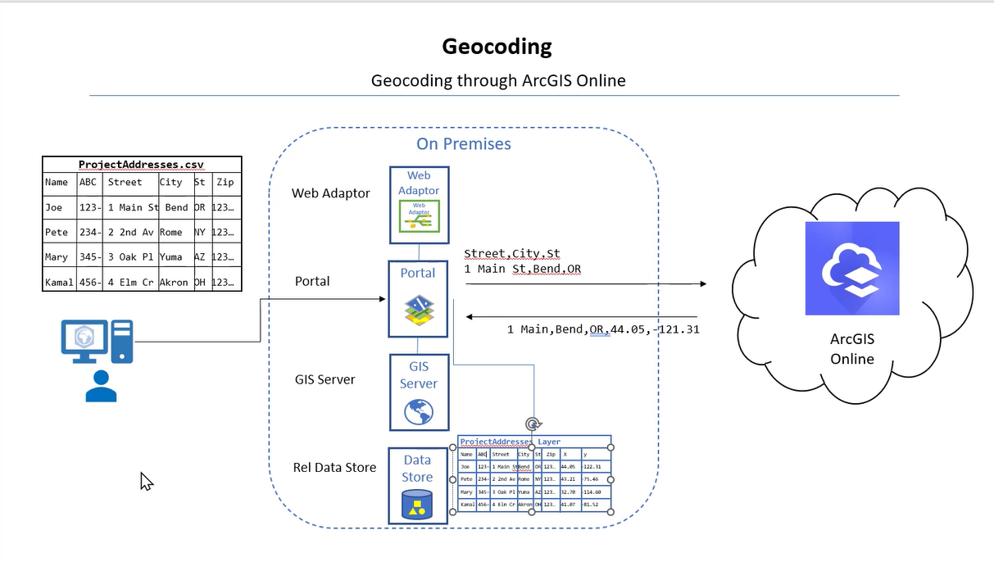

**Frequently Asked Questions (FAQ)**

**1. What is changing with geocoding services?**  
The local geocoding service will be retired, and all geocoding will be conducted through ArcGIS Online. This allows users to continue uploading addresses for geocoding, with coordinates returned for mapping.

**2. How does the one-way connection work?**  
Address data is securely sent to ArcGIS Online for processing. Only the resulting geocoded coordinates (latitude and longitude) return to the portal.

**3. Why is the connection one-way?**  
This setup protects the secure environment from potential vulnerabilities in ArcGIS Online’s FedRAMP Moderate environment, ensuring data integrity.

**4. Is any sensitive data transferred to ArcGIS Online?**  
Only address data is transferred, and once processed, only coordinates are returned. No sensitive data is stored or transferred in ArcGIS Online.

**5. How secure is this connection?**  
The connection is designed to maintain data privacy and security. The one-way structure ensures no data or actions can flow from ArcGIS Online back to the secure portal.

**6. What is FedRAMP, and why is it important?**  
FedRAMP is a U.S. government program standardizing cloud security assessments. The portal operates under FedRAMP High, while ArcGIS Online is FedRAMP Moderate, ensuring secure use of geocoding services while protecting data.

**7. Can users directly interact with ArcGIS Online?**  
No. Users only interact with the portal, and the address data is sent to ArcGIS Online behind the scenes.

**8. Can ArcGIS Online send data or commands back to the portal?**  
No. The connection is one-way, designed to only allow geocoding results to return to the portal, protecting the secure environment.

**9. How can additional credits be requested?**  
Credits are allocated on a first-come, first-served basis. Additional credits can be requested through the intake form when needed.

**10. Can we estimate how many credits a project will need?**  
While exact estimates can be challenging, credits are offered in packs (e.g., 1,000 geocodes for 40 credits), allowing users to purchase based on project needs.

This guide provides an overview of the geocoding workflow and security considerations for the on-premises portal using ArcGIS Online, ensuring both functionality and data security.